What is style transferring?

Style transfer is a technique in computer vision and image processing that involves applying the artistic style of one image (the style image) to another image (the content image), resulting in a new image that combines the content of the content image with the style of the style image. It aims to generate visually appealing images that exhibit the content of one image in the artistic style of another.

Uses of Style Transfer:

Artistic Exploration: Create unique art forms by applying the styles of famous artists or artistic movements to photographs or other images.

Creative Design: Generate stylized graphics, textures, and backgrounds for web design, advertising, and other creative projects.

Image Editing: Enhance photos with artistic effects or add a specific style to match your project's aesthetic.

Entertainment Apps: Mobile apps like Prisma and DeepArt use style transfer to let users create artistic versions of their photos for fun.

Advantages of Style Transfer:

Accessibility: It allows anyone to create art-inspired images without artistic expertise.

Versatility: Works with a wide range of content and style images, enabling exploration of diverse artistic styles.

Customization: You can control the balance between content and style, allowing for subtle or dramatic transformations.

Automation: Style transfer algorithms automate the process, saving time and effort compared to manual artistic techniques.

Applications of Style Transfer

Fine Arts: Artists can use style transfer as a source of inspiration or to experiment with different styles in their work.

Graphic Design: Create visually appealing graphics, textures, and backgrounds for various design projects.

Movie and Video Production: Apply artistic styles to special effects, transitions, and title sequences in films and videos.

Fashion Design: Generate stylized patterns and textures for clothing and accessories.

Medical Imaging: Style transfer can be used to visualize medical data in a more informative or aesthetically pleasing way.

Gram Matrix:

The Gram matrix style transfer technique is a method based on deep learning, specifically convolutional neural networks (CNNs), that is used to transfer the style of one image onto another. It derives its name from the Gram matrix, which is a mathematical concept used to capture the style features of an image.

Here's how the Gram matrix style transfer technique works:

Feature Extraction: A pre-trained convolutional neural network (CNN) like VGG is used to extract features from both the content and style images. These features are activation maps at different layers within the CNN, representing various levels of detail and abstraction.

Gram Matrix Calculation: For the style image, a gram matrix is calculated for each feature map. The gram matrix captures the style information, which is the inherent relationship or correlation between the activations in the feature map. It essentially encodes how often certain combinations of feature values appear together, disregarding the spatial arrangement of these features.

Loss Function: Two loss functions are used to guide the style transfer process:

* Content Loss: Measures the difference between the features of the generated image and the content image, ensuring the generated image retains the objects and shapes from the content.
* Style Loss: Compares the gram matrices of the generated image and the style image at corresponding layers, forcing the generated image to adopt the statistical style properties of the style image.

Optimization: An optimization algorithm iteratively adjusts the generated image to minimize the combined content and style loss functions. This process essentially nudges the generated image towards resembling the content image in structure while incorporating the style statistics from the style image.

Advantages of the Gram Matrix Style Transfer Technique:

Preservation of Global Style Features: The Gram matrix technique captures global style features such as texture, color distribution, and patterns, allowing for more accurate style transfer compared to methods that only consider local features.

Efficient Style Representation: The Gram matrix provides a compact representation of style features by capturing statistical correlations between different features. This leads to more efficient style transfer algorithms that can process images more quickly.

Control over Style Transfer: The Gram matrix technique offers more control over the style transfer process, allowing users to adjust the strength of style transfer and customize the final output according to their preferences.

Compatibility with Deep Learning Frameworks: The Gram matrix technique is compatible with deep learning frameworks such as TensorFlow and PyTorch, making it easy to implement using existing libraries and tools.

Quality of Results: When properly implemented and fine-tuned, the Gram matrix style transfer technique can produce high-quality results with visually appealing stylized images that effectively combine the content of one image with the style of another.

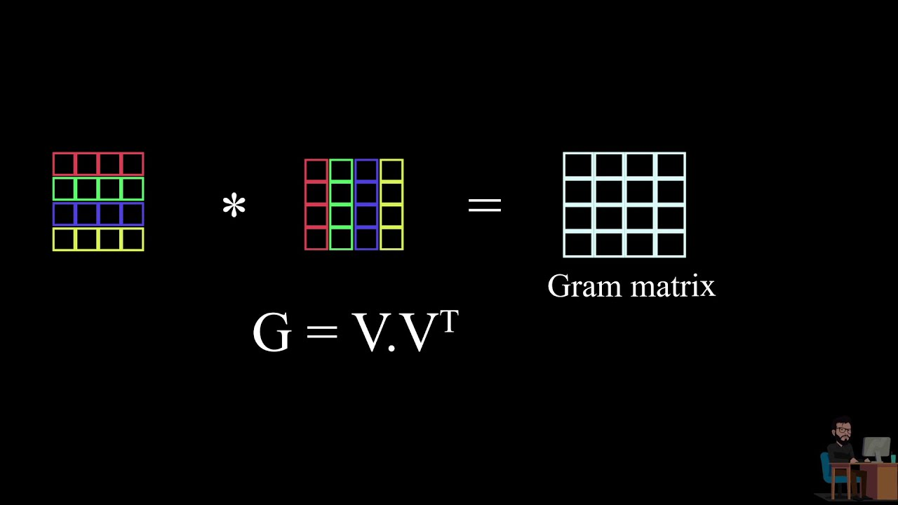

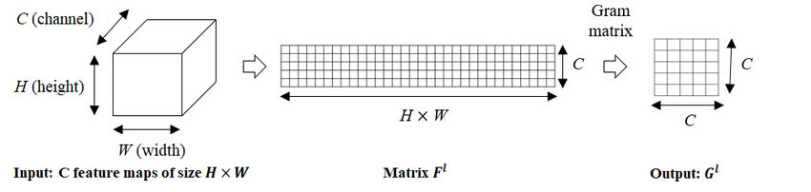

2 Style Transfer Algorithm

Terminology to be used while using Style Transfer Algorithm.

* Content Image : the image where style need to applied.
* Style image : The image that contain the style we need to transferred
* Target image: the final image where the style is applied to the content image.

Step 1: The target image is the pure noise

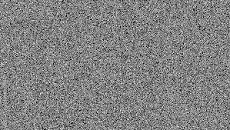

here the model is not trainable means we don't train the network

we will train the image

Backpropagation will slowly transform the target image.

step2:

pick the pre-trained CNN network

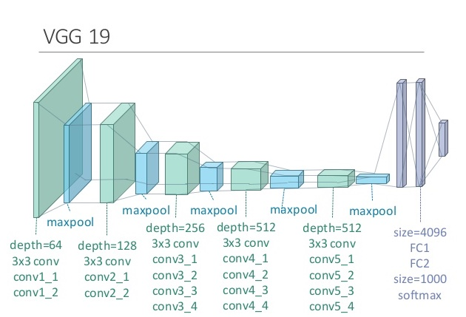

VGG19 Convolutional Neural Network for Content and Style Representation

step3:Match content("pixel-level" feature mapping)

here loss function is

step4:Match Content("texture-level" feature mapping)

Entire algorithm has two stages:

* Preparation Stage:
  + Import and Freeze Pretrained CNN
  + import and transform(for the image size) images(content and style image)
  + Make a trainable trainable image using random numbers
  + a separate functions to Compute feature maps and Gram matrices
* Training Stage
  + pass the content and target image through the CNN model

to extract the target feature activation maps from the layers that you want to train.

* + Compute the contentMSE : between the target and content images

this step useful for matching the pixel values.

* + compute the gram metrix of the style feature maps and target activation feature maps.

for the want ever layers you are using to train.

those gram matrixes will be different for each layer

* + compute the StyleMSE: between the targetgram and style gram
  + loss function = contentMSE + StyleMSE

this the loss the model uses for the back propagation

* + Backpropagation on the target image and here we are not backpropagating on the network.

this training state is the one epoch of training.

Meta-Parametes to be considered

| **Meta-Parameter** | **Effect on Style Transfer** |
| --- | --- |
| No of training epochs | More epochs --> more refinement |
| Layer(s) for content matching | Earlier Layers --> more details preserved |
| Layers and weights for style | Model Performance and quality of Image |
| style loss gain factor | Strength of the style Transfer |
| Model Architecture | ex: mean-pool insted of the max-pool |

3 Implementation Details:

3.1 Server side application:

3.1.1 VGG19 Model:

The torchvision library is utilized to import the VGG19 model pretrained on ImageNet.

VGG19 is employed for feature extraction from both content and style images.



VGG19 Convolutional Neural Network for Content and Style Representation

Trainable Target Image:

The target image is initialized as a trainable parameter, allowing the algorithm to modify it during optimization.

Loss Functions:

Content Loss: Calculated using Mean Squared Error (MSE) between content features of the target and content images.

Style Loss: Utilizes Gram matrices for style comparison, weighted by a style strength factor (1e6).

Layer Selection and Layer Strength:

Specific layers in the VGG19 model are chosen for style loss calculation based on empirical observations.

Layer strength parameter is introduced to control the influence of each layer on the style loss, allowing for fine-tuning of style transfer results.

Optimization:

RMSE is employed as the optimization criterion to preserve details in the stylized image.

An RMSE optimizer with a learning rate of 0.005 is utilized for efficient optimization.

The target image is updated iteratively to minimize both content and style losses.

API deployment of style transfer algothiron:

Create FastAPI App:

* Define your FastAPI application, including routes for receiving requests and serving responses.
* Implement endpoint(s) for uploading content image, style image, and style strength, and returning the stylized image.

Implement Style Transfer Algorithm:

* Implement your style transfer algorithm within the FastAPI app.
* This should include loading the pre-trained VGG19 model, defining the loss functions, and performing optimization to generate the stylized image.

Upload the Model and Necessary Files to github:

* Upload your pre-trained VGG19 model and any other necessary files (e.g., weights, configurations) to your server or cloud storage.

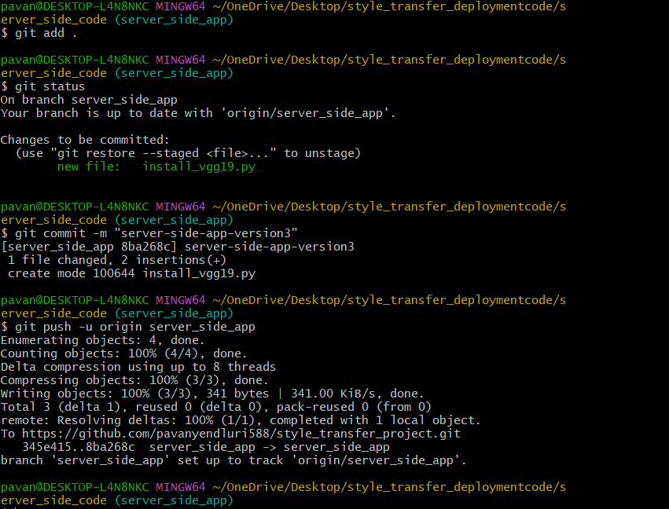

Define Dockerfile:

* Create a Dockerfile that specifies how to build the Docker image for your FastAPI app.
* Include instructions to install dependencies, copy your code and model files into the container, and expose the necessary ports.

**Server-side-app-Dockerfile:**

**client-side-app-Dockerfile:**

Build Docker Image:

* Build the Docker image using the Dockerfile you created.
* This can be done using the docker build command.
* Pushing the docker image to the docker registery.

**Commands to build Docker image from docker file:**

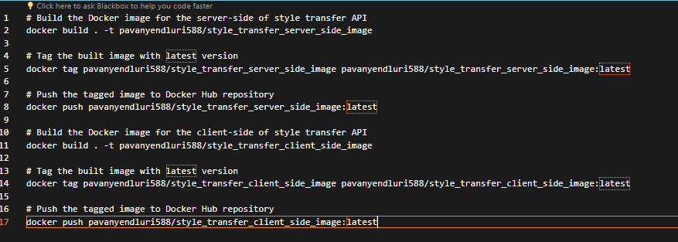

Test API Endpoints:

* Test your API endpoints to ensure they are correctly receiving requests and returning responses.
* Use tools like cURL or Postman to send test requests to your API.

Running the style_transfer_server_side_image to test the working of API:

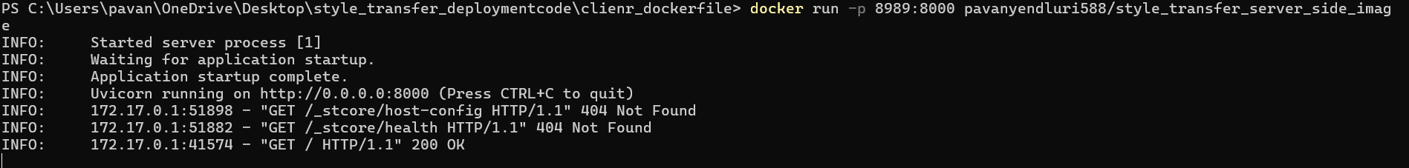

Testing Basic API response from the container:

**Deploy to Cloud Platform:**

* **Push Docker Image to Docker Hub Registry**

Push the Docker image containing your style transfer API to a Docker Hub registry for easy access and distribution.

* **Deploy Docker Container to Azure App Service**

Utilize Azure App Service to deploy the Docker container hosting the style transfer API, leveraging its efficient scaling and monitoring capabilities.

* **Efficient Scaling and Monitoring**

Benefit from Azure App Service's built-in services for efficient scaling and monitoring of your deployed API, ensuring optimal performance and resource utilization.

* **Cost of Deployment**

Enjoy cost-effective deployment with Azure App Service, with pricing starting at $2 per month, making it suitable for various budget constraints for enabling auto scaling.



* **Automated Scaling**

Leverage Azure App Service's automated scaling capabilities to dynamically adjust resources based on demand, allowing your API to handle fluctuations in traffic seamlessly.

Configure API Gateway (Optional):

* If deploying to a cloud platform, configure an API gateway to manage incoming requests and route them to your FastAPI service.
* This allows for better scalability, security, and monitoring of your API.

Monitor and Maintain:

* Monitor the performance and usage of your deployed API to ensure it meets the desired quality of service.
* Regularly update and maintain your API and underlying infrastructure as needed.

API Key Metrics Dashboard